Title of Your Abstract (Times 14 points bold)
<<one blank line>>
Full Name of Author(s) (Times 14 points)
The name of corresponding author is underlined
<<one blank line>>
Affiliation(s) of Author(s) (Times 12 points Italic)
with full postal address
Corresponding author email
<<one blank line>>
This document indicates an abstract format of LEEM-PEEM 14.
The abstract should explain the contents of your presentation clearly. All the abstract must be written in English. The body of abstract should be typed in single-space format with 12 point Times Font. The abstract should be written in one-page of A4 (or US letter size) paper, and 1 inch margin is required. A clear contrast is recommended for image data. Reference citations are shown in the text by a number in brackets, and the reference list is typed below the body text in times 10.

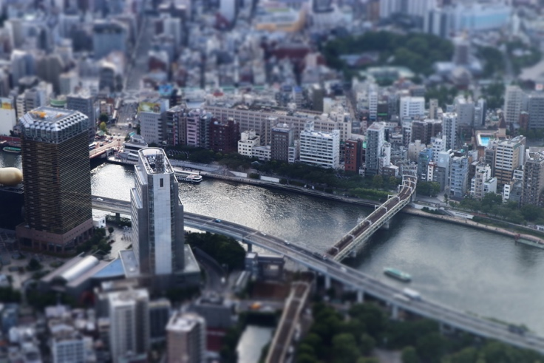
Fig 1. Figure caption will be inserted here. The size of the figure can be adjusted as needed.
Reference(s)
[1] Authors names, Journal Title, volume, page (year).

